
ILingual CASE Tool

The WinTech ILingual Computer Aided System Engineering (CASE) Tool provides an environment for the rapid development of Multi-Lingual Internet Business Solutions. It provides the application programmer with a layer of abstraction from the source code to insure consistency, efficiency and standardization. The ILingual CASE Tool provides full support for all User, Business and Data Services.

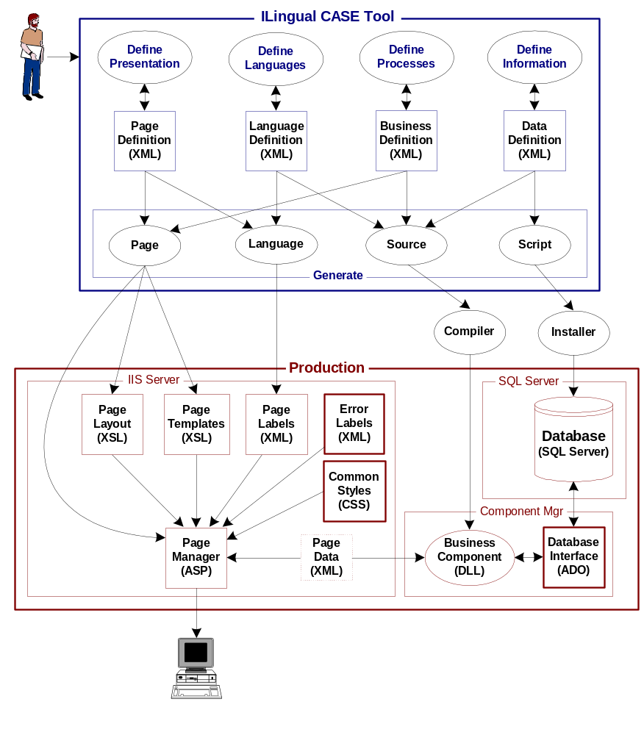

The ILingual CASE Tool
The ILingual CASE Tool provides a user interface for the definition, maintenance and construction of the User, Business and Data Services for an Application. ILingual executes several processes in order to generate the complete system including; page generation, language generation, business generation and data generation as defined in the specific ILingual applets.

Page Designer
The Page Designer supports the definition of web pages for the presentation and collection of business information. The generated web pages support a dynamic interface to environment variables, runtime data values and foreign language text labels. The Page Definition is stored in an XML file.

Page Generation
A Page Layout XSL file is produced which includes all the instructions to produce the HTML to be sent to the client browser. A Page specific JavaScript File is also produced for client side validation of the web page. All execution logic for the web page is created in a Page Manager ASP File. The Page Manager contains the logic to send and receive the web page and to interface with the Business Component to execute transactions. The Page Manager ASP File is installed on IIS and references all the necessary related files based on the client language settings and the browser platform, including; the Page Layout XSL File, Page JavaScript File, Page Labels File, Common JavaScript File, the Common Styles File and the optional Page Data XML memory file. See the Page Definition Language document for a detailed description of the XML file options.

Language Manager
The Language Manager supports the definition of text labels in multiple languages to be used on all web pages and user interfaces. The Language Manager uses the language text labels along with the Page Definitions to generate a separate XML Language Label File for each web page and language combination.

Language Generation
The Page Definition File is used along with the Language Label File in order to produce a separate Page Label File for every Web Page and Language combination defined.

ILingual Architecture

Business Design (Logical View)
Solution User Services Tool - User / Business / Data
Solution Business Services Tool - User / Business / Data
Solution Data Services Tool - User / Business / Data

Technical Design (Physical View)
Solution User Services Tool - User / Business / Data
Solution Business Services Tool - User / Business / Data
Solution Data Services Tool - User / Business / Data

 | Solution
 | User | Business | Data

ILingual
Business Design
User | WTU_User  WTU_Table  WTU_Lang | WTU_Busn | WTU_Data
Business | WTB_User  WTB_Table  WTB_Lang | WTB_Busn | WTB_Data
Data | WTB_User  WTB_Table  WTB_Lang | WTB_Busn | WTB_Data
Technical Design
User | WTU_User  WTU_Table  WTU_Lang | WTU_Busn | WTU_Data
Business | WTB_User  WTB_Table  WTB_Lang | WTB_Busn | WTB_Data
Data | WTB_User  WTB_Table  WTB_Lang | WTB_Busn | WTB_Data

